Final RSI Backtest Strategy (Corrected)
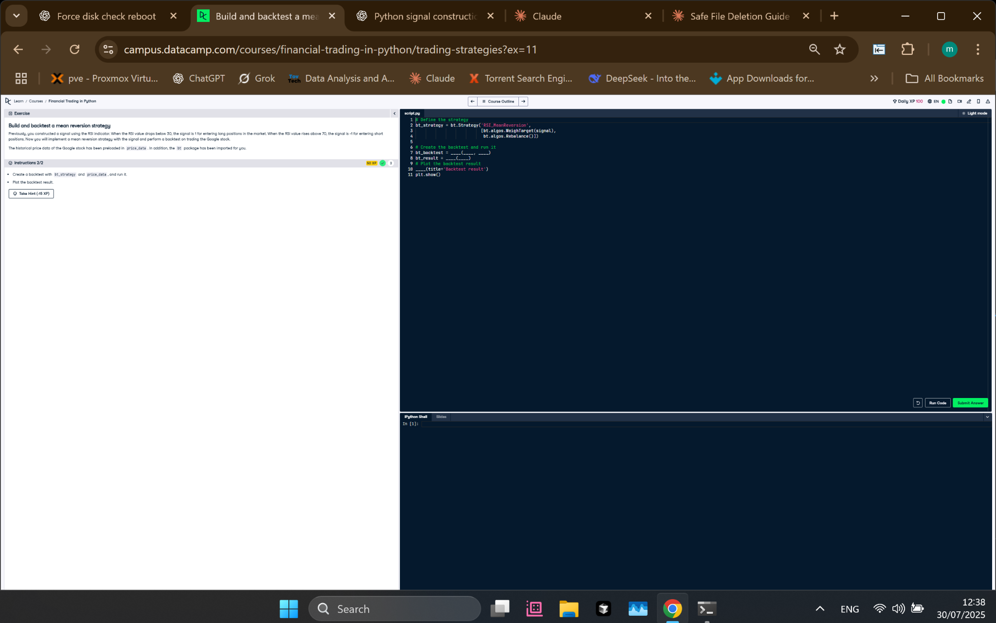
Figure: Corrected backtest setup applying only target weights and rebalancing.

Python Code
# Define the strategy
bt_strategy = bt.Strategy('RSI_MeanReversion',
[bt.algos.WeighTarget(signal),
bt.algos.Rebalance()])
# Create the backtest and run it
bt_backtest = bt.Backtest(bt_strategy, price_data)
bt_result = bt.run(bt_backtest)
# Plot the backtest result
bt_result.plot(title='Backtest result')
plt.show()

Explanation
This final version defines a strategy using only `WeighTarget(signal)` and `Rebalance()`. It assumes the signal has already been filtered (non-tradable assets are set to 0), so there's no need for a separate selection step. The strategy is executed on historical price data, and the performance is visualized using `bt_result.plot()`.

